Handling Null
- Handling null values
  - Null means unknown value so we need to handle it separately at all condition.
- Arithmetic operators doesn’t work with null in sql.
  - = Null return only empty result set “is null” or “is not null “is correct.
- To check null value v can use isnull isnull( column,0)
- We can perform agg function with the null values like sum(),count()
- Concat and +
  - while performing operation with null values,using + it will return null
  - Concat() will replace the null with “”

Basics
- Primary columns – Unique values.
- And operation – both condition should true
  - Or operation – either one of the condition should true.
- AGG
  - cant’ use in where clause only in select & having
  - aggre function works with number of rows in that column
- Length (only leading space) and data length (both spaces).
- If we use column comparison of two columns using where it will compare the same straight values, for comparison of each and every value of opposite column use join on condition.
On we1.recorddate = dateadd(day,1,we2.recorddate)
- We can use order by with different order for two different column as below
order by percentage desc,contest_id asc
- IIF () FUNCTION can be used to check true or false condition instead of case when we can use this for simple check in the column

- Exits

  - Returns true if one or more resultset returned by the subquery of it
- String_agg
  - String_agg used to concate the string values together based on the group by
  - Syntax
STRING_AGG ( exp, separator) [ <order_clause> ])
STRING_AGG(email,’;’)
WITHIN GROUP (ORDER BY email)
- Offset and fetch clause

  - OFFSET: This clause is used to specify the beginning point for returning rows from a result set. Basically, it ignores the initial set of records. SQL Server can use it only with the ORDER BY clause. If its value is negative, an error will be returned. Therefore, it should always be greater than or equal to zero.
  - FETCH: It is an optional clause that provides the number of rows we want to return after the OFFSET in a query. We cannot use it without OFFSET. Its value cannot be negative similar to OFFSET. Therefore, it should always be greater than or equal to zero; otherwise, it will throw an error.

  - Syntax (https://www.javatpoint.com/sql-server-offset-fetch)

SELECT * FROM table_name
ORDER BY columns [ASC |DESC]
OFFSET no_of_rows_to_skip
FETCH {FIRST | NEXT} no_of_rows_to_return {ROW | ROWS} ONLY
- Order by clause:
  - Be careful with order by clause while using expression in the column, if you’re using expression or function in select statement with alias name and using that alias name in order by clause it will through error. Instead you need to use the complete function with column name becoz sql server processes the order by clause first then the select statement as per chat gpt.
Select * from (
select top 1 city ,len(city) length from station order by len(city),city
union
select top 1 city , len(city) length from station order by len(city) desc,city asc)a
order by length
  - Also while using union you need to use order by clause for over all statement as above else it will through error.

- Function in sql
  - Replace – return varchar
  - Round – allows decimal values to round the value.
It will take next value if decimal value is only greater than or equal to 5.
  - Ceiling- no need to decimal values.it rounded the value to next highest value
It will take the next value of the given number. If decimal value is even less than 5.
  - Abs- return absoulte value of specified number , converts negative number to positive number
  - Floor – it rounded the value to the smallest value or equal to the value given.
  - Replicate – it replicate the specified string in the given number of times

- Float , decimal & int difference
  - Float - cast(1 as float) -1.0
  - Decimal – cast (1 as decimal(10,2) 1.00
  - Int - cast( 10.939 as int) -> 10

- Convert - cast and convert does the same operation but convert accepts the optional parameter stype parameter for formating.
CONVERT(data_type(length), expression, style)

Count Function in sql
- Count(*) - It returns total count of rows in the table including null values
- Count(1) – It replaces all the row values into 1 and returns total count of rows in table including null values
- Count(column_name) – It returns the count of rows in table excluding the null values.
- Count(distinct(column_name)) – it return only the distinct count excluding null values.

Joins
- Nulls with Join
  - If there Is no values in the base table for the column that we use to join the table then I will set null values to the column that has empty value.
ca.rpt_nme = sort.rpt_nme
- Cross join – return all the records from both the table
- if we are joining 3 tables it is important to connect all the 3 tables using “on condition” else will get duplicate values
- we can also use subquery to join the base table

-----------------------------------------------------------------------------------------

Working with Date
- To compare two date columns during joins we need to use date function , no arithmetic operations or agg function works with date.
  - Datediff
  - Dateadd
  - dateName & datepart – both does the same operation only difference is datename returns string based result where datepart returns integer based results

Aggregate functions
- Avg -takes the average of particular column data.
- Count – count the total of column values
- Round – round off based on the decimal value we give
- Use % to validate the remainder since it return the remainder as result where / returns quotient
CTE
- Common table expression (CTE) is temporary name resultset that we can use for following select,insert ,update or delete statement.
- Syntax
WITH expression_name [ ( column_name [,...n] ) ]
AS
( CTE_query_definition )

SET Operators in SQL

- Union – used to combine two or more select statements, resultset will have only distinct values.
- Union all – same but allow duplicates

------------------------------------------------------------------------------------------------------------------------------------------

(Advanced SQL)
- Window Function
https://www.sqlshack.com/use-window-functions-sql-server/

- Window function operate on set of rows and returns a single aggregated value for each row.
- Types
  - Aggregate windo functions using sum(),max(), min(), avg() , count()
  - Ranking window finction using rank(),dense_rank(),row_numer(), ntile()
  - Value window functions using lag(),lead(),first_value(),last_value().
- Syntax
window_function ( [ ALL ] expression )
OVER ( [ PARTITION BY partition_list ] [ ORDER BY order_list] )

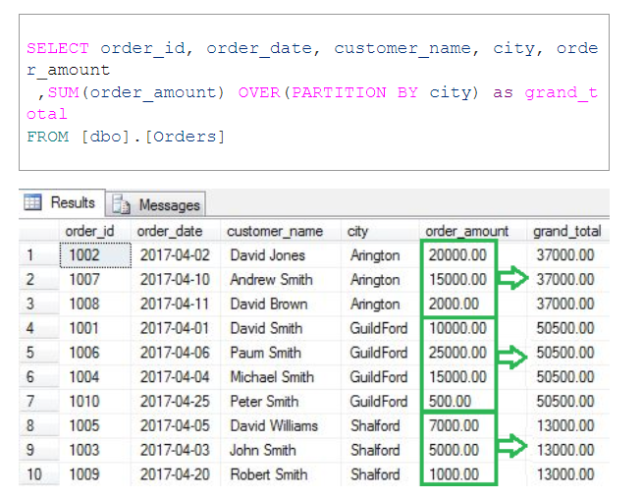

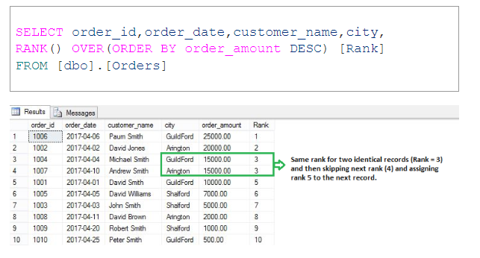
- Rows between in window function
(https://www.geeksforgeeks.org/sql-rows-between/)
  - Rows between used to measure the running aggregation.
  - UNBOUNDED PRECEDING: All rows before current row are considered.
UNBOUNDED FOLLOWING: All rows after the current row are considered.
CURRENT ROW: Range starts or ends at CURRENT ROW.
n PRECEDING – n rows before the current row.
n FOLLOWING – n rows after the current row.

Parameters | Description
rows between Unbounded Preceding and Current Row | includes the current row and all rows before current row
rows between N Preceding and Current Row | includes the current row and a specified number of rows before current row
rows between current and current row | includes only the current row
rows between N Preceding and M Following | includes specified rows before and after the current row
rows between Current row and M Following | includes the current row and a specified number of rows after current row
rows between Current Row and Unbounded Following | includes the current row and all rows after current row

- Lead & lag in widow function

  - LEAD(expression, offset, default) OVER (ORDER BY order_expression)
  - The expression parameter is the column you want to access from the next row, the offset parameter specifies the number of rows ahead you want to access, and the default parameter is the value to return if there is no next row. The ORDER BY clause specifies the order of the result set.
  - LAG(expression, offset, default) OVER (ORDER BY order_expression)
  - The LAG function is used to access data from the previous row in a result set. The syntax of the LAG function is similar to the LEAD function.

- COALESCE() – It returns the first non-null value in the list
Syntax:
Coalesce( null,10,20) ->10

